Cyber Guard: Detection of Cyber Threats Using Random Forest,
Multi-layer Perceptron
Nagarapu Sandeep³
Computer Science and Engineering(Cyber Security)
Institute Of Aeronautical Engineering,Dundigal
Hyderabad, Telangana,
India
sandeepnagarapu11@gmail.com
Sambu Vyshnavi²
Computer Science and Engineering(Cyber Security)
Institute Of Aeronautical Engineering,Dundigal
Hyderabad, Telangana,
India
vyshnavisambu@gmail.com
Mr.A.Srikanth¹
Computer Science and Engineering
Institute Of Aeronautical Engineering,Dundigal
Hyderabad, Telangana, India
a.srikanth@iare.ac.in

Saindla Rithish⁴
Computer Science and Engineering (Cyber Security)
Institute Of Aeronautical Engineering,Dundigal
Hyderabad, Telangana,
India
rithishs2004@gmail.com

Abstract: Cyber-Guard is a smart, machine learning-based system designed to detect cyber threats before they happen. By combining the strengths of Random Forest and Multi-Layer Perceptron (MLP) algorithms, it detects suspicious patterns in data that may indicate a potential threat. This technology aims to improve cybersecurity by making malware and other threats detection faster, more accurate, and less reliant on human input. With the rise in online threats, especially in sensitive sectors like healthcare, Cyber-Guard offers a proactive solution to safeguard personal and organizational data. It uses real-world datasets and focuses on minimizing risks such as identity theft and financial loss, helping organizations stay ahead of evolving cyber threats.
Keywords: Machine learning framework, Random Forest, Multi Layer Perceptron, pattern recognition, cyber threats, data protection
- INTRODUCTION
"Cyber-Guard" is an innovative machine learning framework designed to anticipate and mitigate cyber threats. By leveraging the capabilities of Random Forest and Multi-Layer Perceptron (MLP) algorithms, it utilizes advanced pattern recognition and classification techniques to detect potential threats. The synergy between Random Forest's ensemble learning and MLP's deep neural network architecture allows Cyber-Guard to analyze complex data patterns accurately. Its adaptability and continuous learning ensure robust defense mechanisms against evolving cyber threats, making it a crucial tool for protecting critical systems and sensitive data.
The emergence of the The digital age has presented opportunities never before possible. for creativity and connectedness. Cyber threats, on the other hand, are becoming an increasingly dangerous threat as a result of it. Cyberattacks have grown more dangerous and sophisticated in recent years, endangering people, companies, and even entire countries. This project aims to comprehensively investigate and analyze cyber threats that occurred in the past year. We will delve into the methods, motivations, and impacts of these breaches to gain a deeper understanding of the evolving landscape of cyber threats.
By examining a range of high-profile cases, we intend to identify common vulnerabilities and attack vectors. Our objectives include mapping the tactics employed by hackers, assessing the effectiveness of security measures, and evaluating the financial and reputational costs incurred by victims. Additionally, we will explore the ethical, legal, and regulatory aspects surrounding cyberattacks and data breaches.
This research not only serves as a valuable resource for cybersecurity professionals but also contributes to raising awareness among individuals and organizations about the importance of robust digital security. By shedding light on the ever-evolving world of cyber threats, we aim to empower stakeholders to fortify their defenses and safeguard their digital assets in an increasingly interconnected world.
- LITERATURE SURVEY
This paper presents a machine learning-based approach to detect cyber threats, addressing the growing need for scalable and efficient cybersecurity systems. The study leverages multiple machine learning models including Random Forest, Decision Tree, k-means, and Multi-layer Perceptron to analyze patterns in cybercrime data and predict potential attacks. The authors highlight the risk posed by increasing cyberattacks across sectors, especially healthcare, where sensitive data is often targeted. Using real-world datasets such as those from the Privacy Rights Clearinghouse, the study emphasizes the need for anomaly-based and hybrid detection models to improve accuracy and minimize false positives. The findings support the utility of predictive analytics in cybersecurity and propose enhanced training and awareness to further reduce breach risks. [1]
Xu and his team focus on modeling and predicting cyber hacking breaches using long-term statistical data spanning over a decade. Their study critiques earlier assumptions that breach inter-arrival times and breach sizes follow simple distributions, showing instead that these metrics exhibit autocorrelation and must be modeled using stochastic processes. The paper introduces models for both breach timing and severity prediction, offering a new perspective on cyber threat evolution. Notably, their analysis indicates that while the frequency of attacks is increasing, the scale of impact has not grown proportionately. This nuanced insight into hacking trends enhances the understanding of cybersecurity risks and informs the design of more responsive protection frameworks. [2]
In their study, Depuru et al. propose a machine learning-based framework for malware classification to aid in the early prediction of cyber hacking breaches. The researchers utilize the Random Forest algorithm, training it with URL-based data to distinguish between legitimate and malicious activities. Achieving a training accuracy of 99% and a testing accuracy of 91%, the model exhibits strong potential for real-time cybersecurity applications. This research contributes to the growing body of work on URL-based breach prediction systems and demonstrates the feasibility of deploying lightweight, accurate, and scalable machine learning tools in practical threat detection systems. [3]
This work addresses the pressing issue of sophisticated cybersecurity threats by developing a Random Forest Classifier-based system for predicting and detecting cyber hacking breaches. The model is trained on a carefully constructed dataset of 5457 URLs, evenly split between phishing and legitimate entries. The emphasis is placed on maintaining high accuracy while reducing false positives. The system achieves a training accuracy of 99% and a testing accuracy of 91%, confirming its robustness and real-world applicability. The authors demonstrate that such machine learning-based models can provide early warnings and actionable insights, offering organizations a valuable layer of defense against evolving digital threats. [4]
Reddy and Alekhya investigate cyber breach patterns by analyzing historical malware attack data from 2005 to 2017. Their study reveals that traditional distribution-based models are inadequate for representing the complex nature of cyberattack timelines and severity. Instead, they propose the use of stochastic process models, which can better capture autocorrelations and enable accurate prediction of attack intervals and sizes. By combining qualitative and quantitative analyses, the authors shed light on the evolving nature of cyber threats, emphasizing the need for dynamic modeling techniques in breach forecasting. Their work lays the foundation for predictive models that can adapt to the changing behavior of cyber attackers. [5]
- PROPOSED METHOD
The proposed method uses different machine and deep learning classifiers for the prediction of cyber attacks, and their performance is calculated. Different classifiers, such as random forest , multilayer perceptron, and autoencoder, are used to calculate the performance. It is observed that MLP and RF are giving superior performance compared to the autoencoder classifier.
The proposed method has the below steps:
Dataset collection of cyber threats
- Dataset Pre-processing : Normalization and Splitting
- Training the different classifier
- Testing different classifiers
- Performance calculation
- Selection of the best classifier for prediction
- Prevention measures
Dataset pre-processing
Training different classifier
Testing different classifier

Performance calculation
Selection of best classifier for detection
Prevention measures

Fig.3.1 Flowchart
3.1. Dataset Collection of Cyber Threats
This step is about gathering real data that shows both safe and unsafe online behavior — like normal internet use and different types of hacking activities. This data helps us teach the system what’s good and what’s bad. We usually use publicly available cybersecurity datasets or logs collected by companies.
3.2. Dataset Preprocessing: Normalization and Splitting
Before using the data, we clean it up and get it ready. Sometimes the numbers in the data are too big or small compared to each other, so we scale them to the same level (this is called normalization). Then, we divide the data into two parts: one to teach the system (training data) and one to check how well it learned (testing data). This way, we can make sure the system doesn’t just memorize but actually understands.
Input Segmented image
Convolutional layer
Flatten layer

Dense layer

Dropout layer

Spatial Feature Extracted

Fig 3.2 Preprocessing
3.3. Training Different Classifiers
Now we start teaching the system using different smart techniques (called classifiers):
Random Forest (RF): Think of this like many small decision trees working together to make a smart group decision.
Multi-Layer Perceptron (MLP): A type of artificial brain that learns complicated patterns from the data.
Autoencoder: A tool that learns how to find strange or unexpected behavior (anomalies) on its own.
Each of these models tries to learn the difference between normal online activity and harmful behavior.
3. 4. Testing Different Classifiers
After teaching, we check how well the system performs on new, unseen data. This is like giving the system a surprise quiz to see how much it really learned. It predicts whether the activity is a cyber threat or not, and we check if the predictions are right.

3.5. Performance Calculation
To figure out which model did the best job, we look at four key things:
Accuracy: How often it got the answer right.
Precision: How good it is at not calling normal activity a threat by mistake.
Recall: How well it catches actual threats.
F1-Score: A combined score that balances precision and recall.
We use charts and graphs to compare the results so it’s easy to see which model is most reliable.
3.6. Selection of the Best Classifier for Prediction
Once we compare everything, we choose the model that performed best—usually Random Forest or MLP. This model will be used going forward to detect cyber threats because it’s proven to be the most trustworthy and accurate.
3.7. Detection of Cyber Threats
Now the system is ready to work in real-time. It takes new data, checks it, and tells us whether it thinks something suspicious is happening. The results are shown in a simple, easy-to-use screen, so even non-technical users can understand.
3.8. Prevention Measures
When the system finds a threat, it doesn’t stop there. It also suggests actions to stay safe—like blocking the source of the attack, alerting security teams, or starting automatic protections. This makes the system proactive, not just reactive.

- RESULTS ANALYSIS
The proposed method uses different machine learning and deep learning algorithms for the detection of cyber threats. Different algorithms used in this application are random forest , autoencoder, and MLP (multi-layer perceptron) classifier.
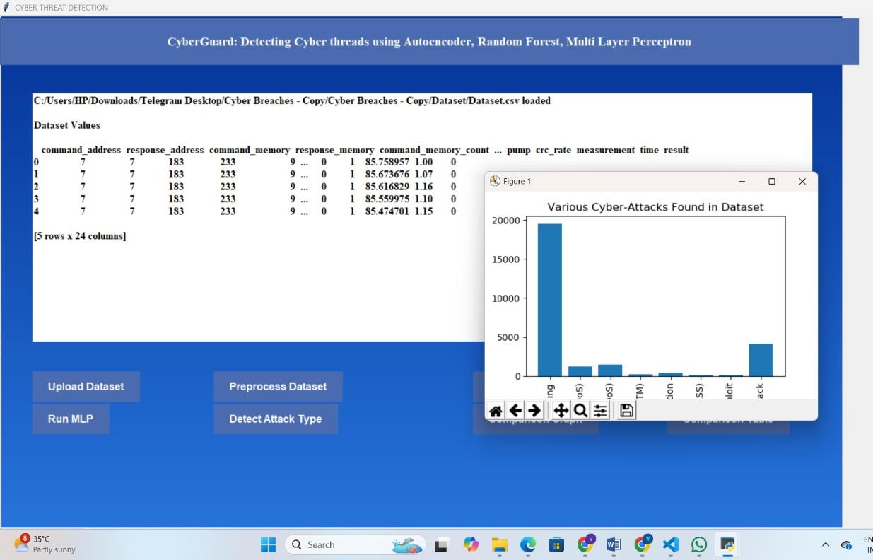
Fig.4.1 Dataset is loaded.
The first 5 rows from the dataset are shown in the above text box on the GUI. GUI is used for easy understanding.
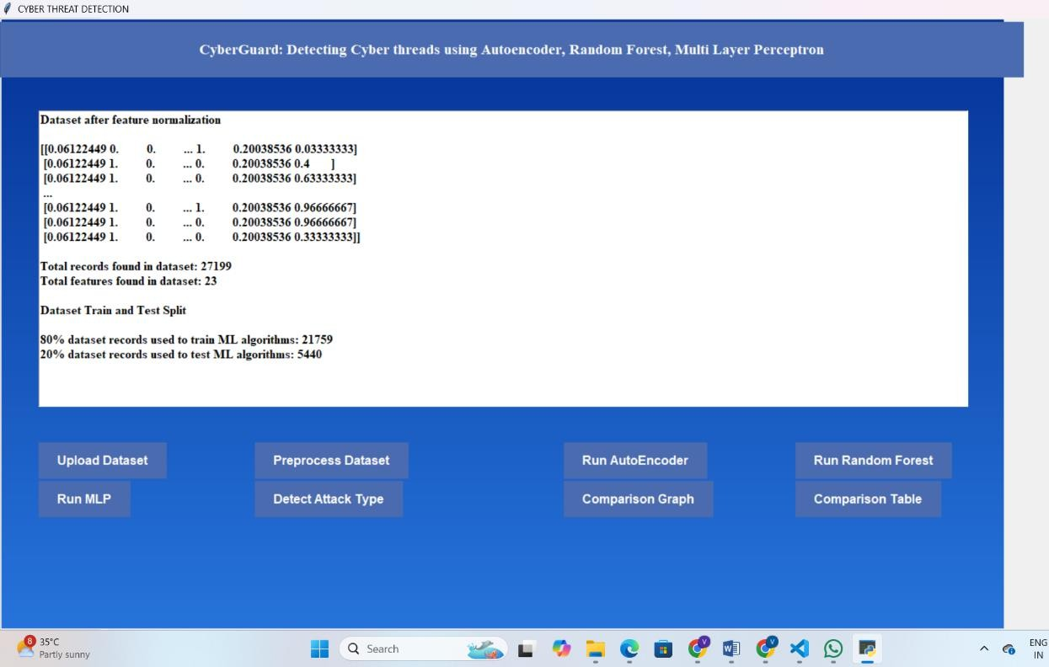
Fig.4.2 Dataset Preprocessing
Preprocessing includes normalization and data splitting. Normalization helps to bring data to certain range to reduce computational complexity.
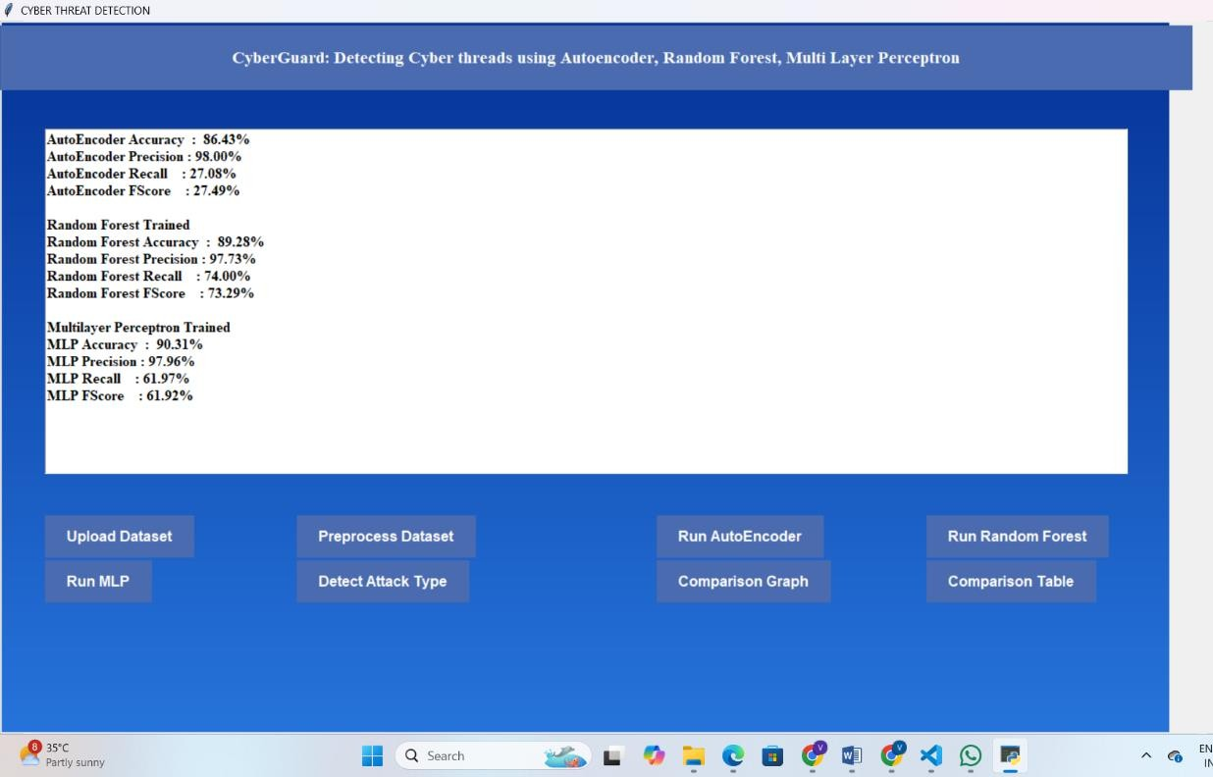
Fig.4.3 Performance calculation of different classifiers
Here, performance metrics such as accuracy , precision , recall, and F-score are calculated to understand which classifier works better for cyber breach identification. The classifier that is giving better performance is used for further prediction. It is observed that random forest and MLP are working better than autoencoder method.

Fig.4.4 Predicted cyber threat by MLP and RF
For given test data both MLP and RF classifier based prediction is performed and predicted results are shown in above GUI text box.
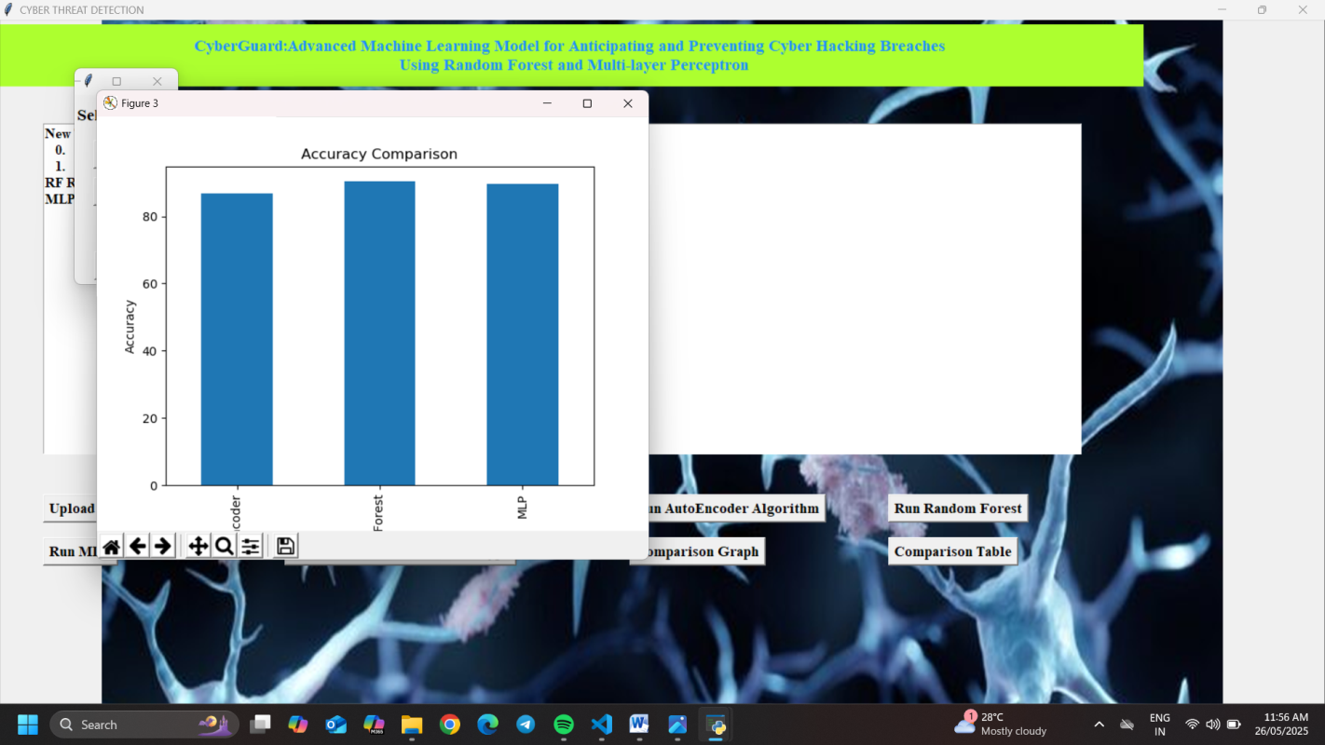
Fig.4.5 Bar Graph for Accuracy Comparison
The above bar graph shows a comparative analysis of the accuracy metric for autoencoder, random forest, and MLP. From the above bar graph, it is observed that MLP and RF are working superior compared to autoencoder classifier.
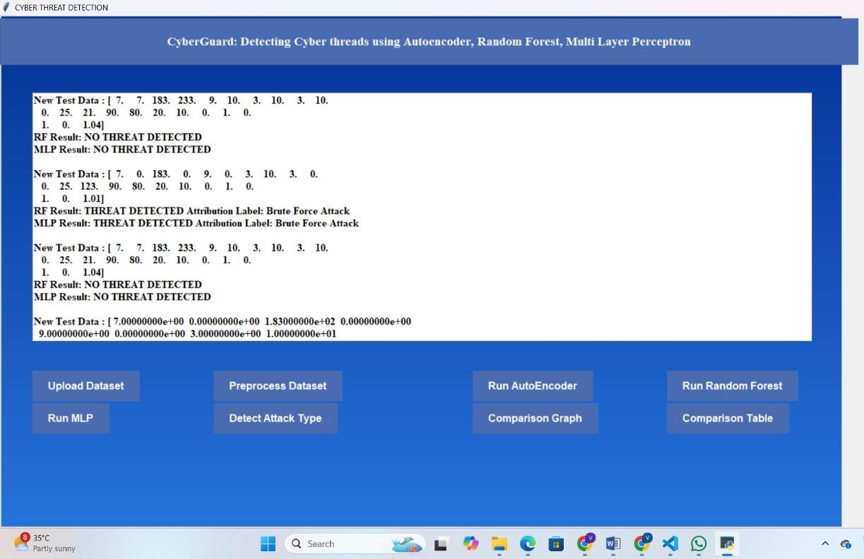
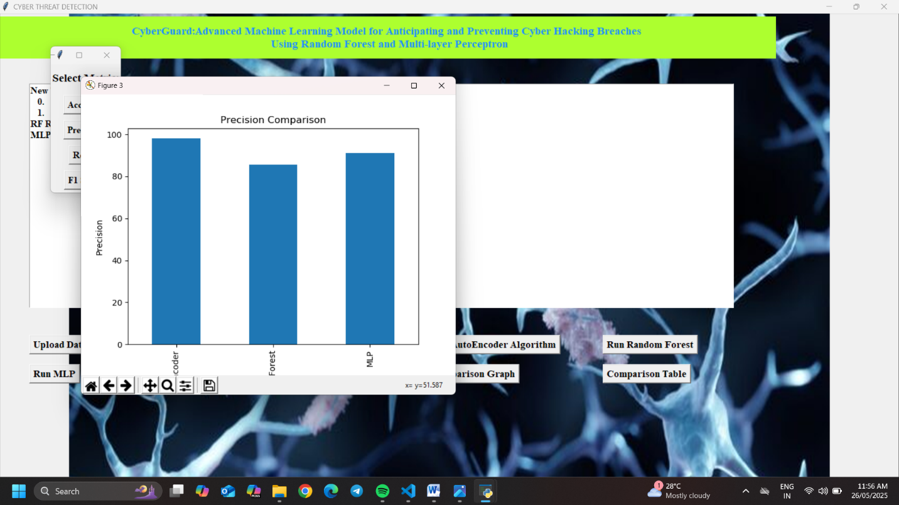
Fig.4.6 Bar Graph for Precision Comparison
The above bar graph shows a comparative analysis of the precision metric for autoencoder, random forest, and MLP. From the above bar graph, it is observed that MLP and RF are working superior compared to autoencoder classifier.

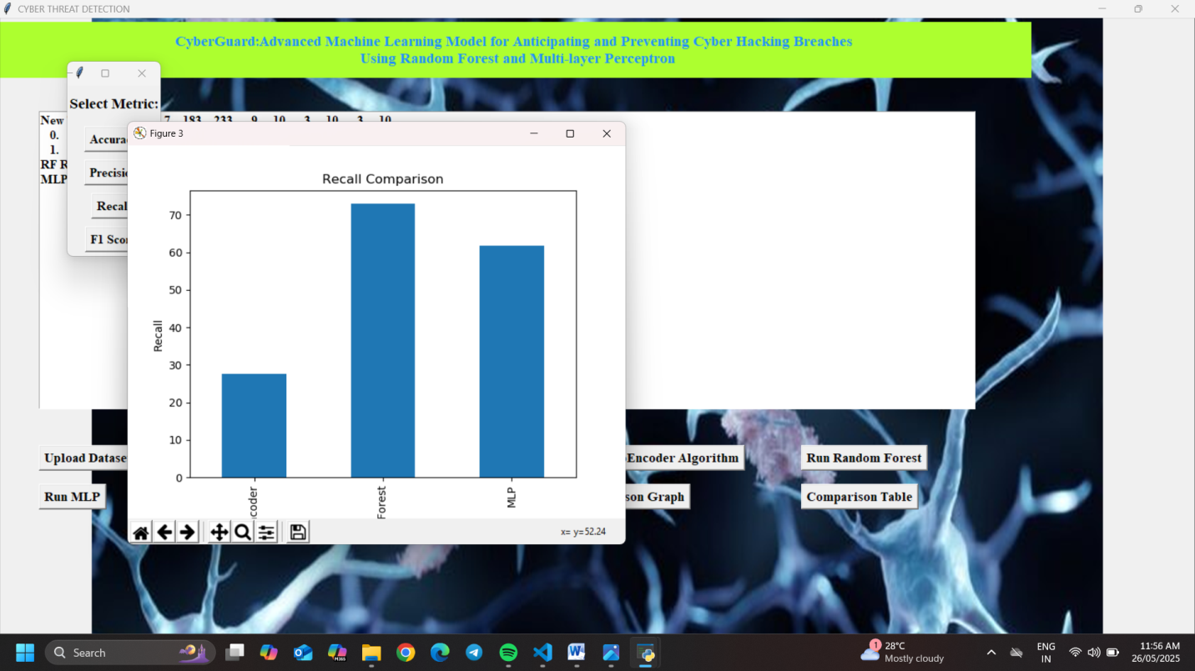
Fig.4.7 Bar Graph for Recall Comparison
The above bar graph shows a comparative analysis of the recall metric for autoencoder, random forest, and MLP. From the above bar graph, it is observed that MLP and RF are working superior compared to autoencoder classifier.

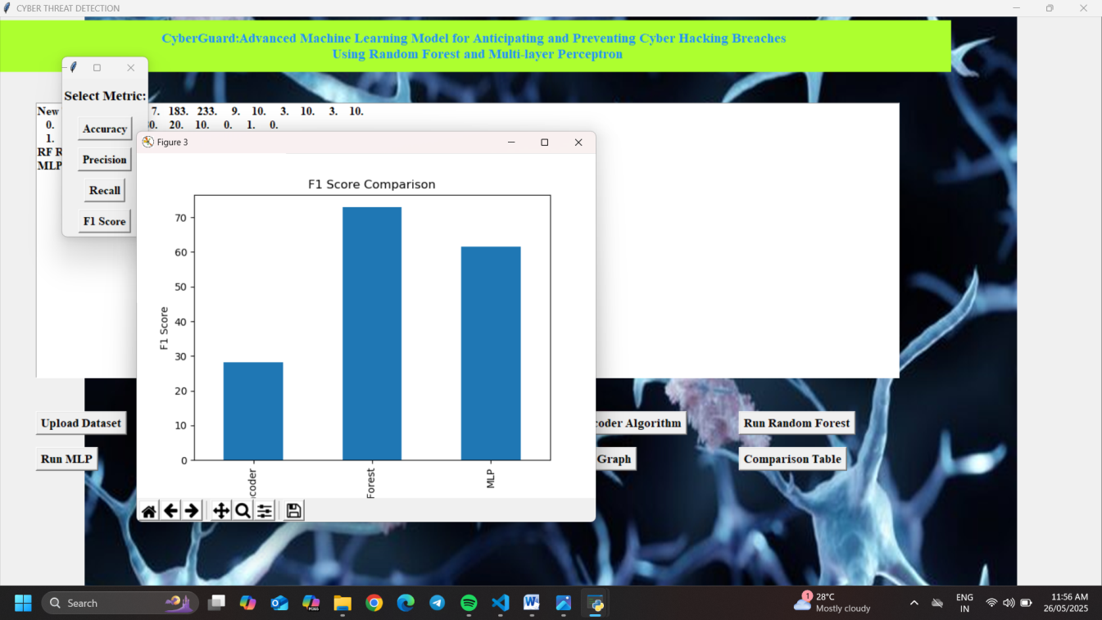
Fig.4.8 Bar Graph for F-score Comparison
The above bar graph shows a comparative analysis of the F1-score metric for autoencoder, random forest, and MLP. From the above bar graph, it is observed that MLP and RF are working superior compared to the autoencoder classifier.

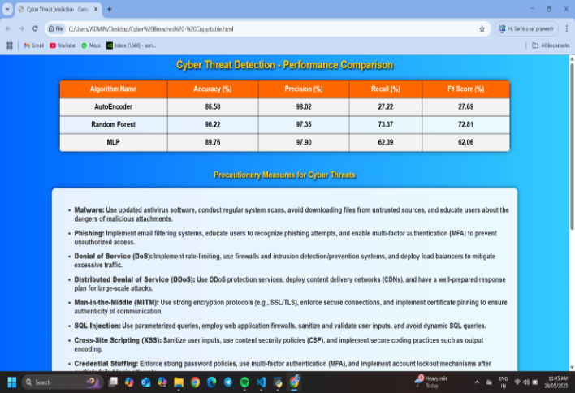
Fig.4.9 Comparison of different techniques and precaution measures
In the above figure, a comparative performance table is shown. Below the performance table, precaution measures are given with respect to the threat detected.
- CONCLUSION
The proposed integration of Random Forest (RF) and Multi-Layer Perceptron (MLP) algorithms forms a powerful approach to cyber threat detection, offering high accuracy, adaptability to varied data types, and proactive defense against evolving attacks. Cyber-Guard utilizes RF’s ensemble stability and MLP’s ability to detect complex patterns, enabling detection and prediction. On the organizational side, time remains a critical resource—impacting everything from employee productivity to project delivery. While traditional attendance systems like manual registers were once the norm, they were often prone to manipulation, especially in large organizations. This has led to the evolution of smarter, tamper-proof attendance tracking solutions in today’s workplaces, reinforcing both accountability and operational efficiency.
REFERENCES
- K Pujitha; Gorla Nandini; K V Teja Sree; Banda Nandini; Dhodla Radhika, “Cyber Hacking Breaches Prediction and Detection Using Machine Learning”, 2023 2nd International Conference on Vision Towards Emerging Trends in Communication and Networking Technologies (ViTECoN), IEEE Conference, 2023.
- M. Xu, K. M. Schweitzer, R. M. Bateman and S. Xu, "Modeling and predicting cyber hacking breaches", IEEE Trans. Inf. Forensics Security, vol. 13, no. 11, pp. 2856-2871, 2018.
- S. Depuru, P. Hari, P. Suhaas, S. R. Basha, R. Girish and. K. Raju, "A Machine Learning based Malware Classification Framework," 2023 5th International Conference on Smart Systems and Inventive Technology (ICCSIT), Tirunelveli, India, 2023, pp. 1138-1143, doi:10.1109/ICSSIT55814.2023.10060914.
- Naaz, Alsaba, Maivis Sheikh, Vaishnavi Narnaware, Sneha Chilkapure, and Kranti Bhatwalkar. "CYBER HACKING BREACHES PREDICTION AND DETECTION."
- Reddy, A. Rama Swamy, and Talasila Alekhya. "Detection of Cyber Hacking Breaches using Machine Learning Algorithm." NeuroQuantology 20, no. 10 (2022): 1654.
- K. Pujitha, Kattamanchi Prem Krishna, K. Amala, annnavarapu Yassine, Sivakumar 14 Depuru, K o p p a ram Run Vika, “Development of Secured Online Parking Spaces”, Journal of Pharmaceutical Negative Results, vol. 13, no. 4, pp. 1010–1013, Nov. 2022.
- H. Hammouchi, O. Cherqi, G. Mezzour, M Ghogho, and M. El Koutbi, “Digging deeper into data breaches: An exploratory data analysis of hacking breaches overtime,” Procedia Computer Science, vol. 151, pp. 1004–1009, 2019.
- Verizon, “Data breach investigations report,” 2019. [Online]. Available : https://enterprise.verizon.com/resources/reports/dbir/
- M. Xu, K. M. Schweitzer, R. M. Bateman, and S. Xu Modeling and predicting cyber hacking breaches IEEE Trans. Inf. Forensics Security, vol. 13, no. 11, pp. 2856–2871, 2018.

